LAB # 03

OBJECTIVE: To learn RMI basics: Generate the stubs and skeletons and run client and server

**LAB TASKS**

Server main class HelloServer.java

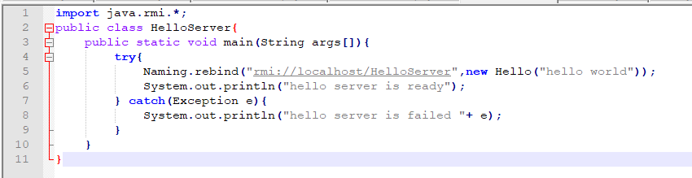

Writing the Remote Object class Hello.java

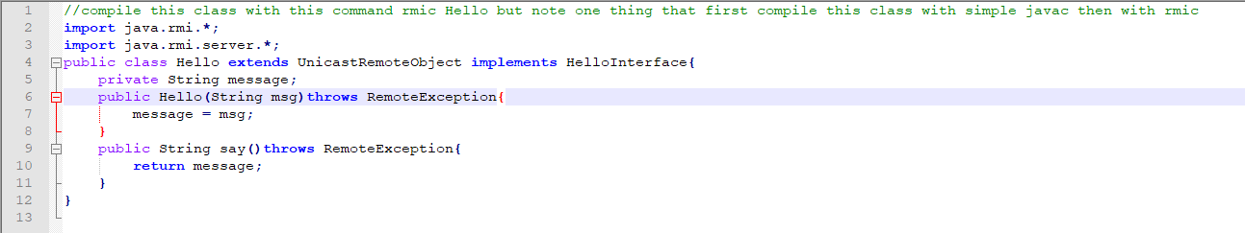

Writing a comman Interfacae HelloInterface.java

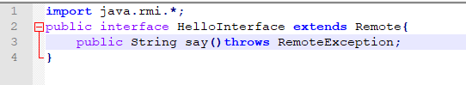

Writing Client Code HelloClient.java

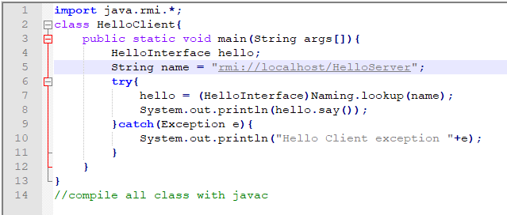

1st Compile All Classes:

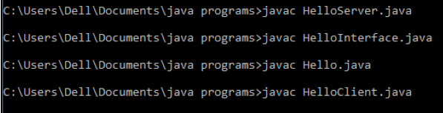

2nd Generate Proxy (Stub) at Server Side:

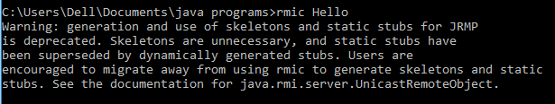

3rd Start RMI REGISTRY:



RMI REGISTRY:

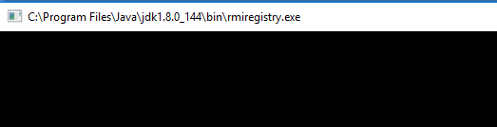

Run HelloServer.java



SERVER OUTPUT:

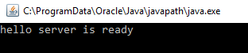

Run HelloClient.java & CLIENT OUTPUT:



TASKS FOR PRACTICAL # 03:

1. Create RMI program in which server performs basic arithmetic operations.

HelloServer.java

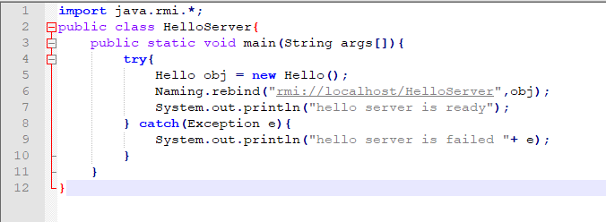

HelloClient.java

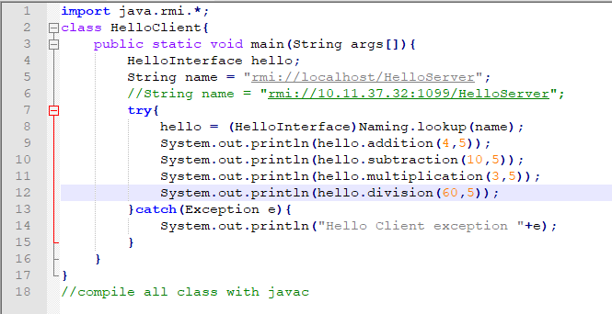

HelloInterface.java

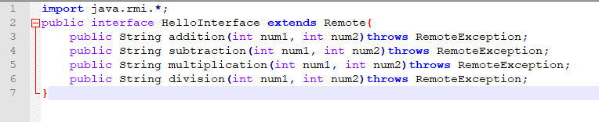

Hello.java

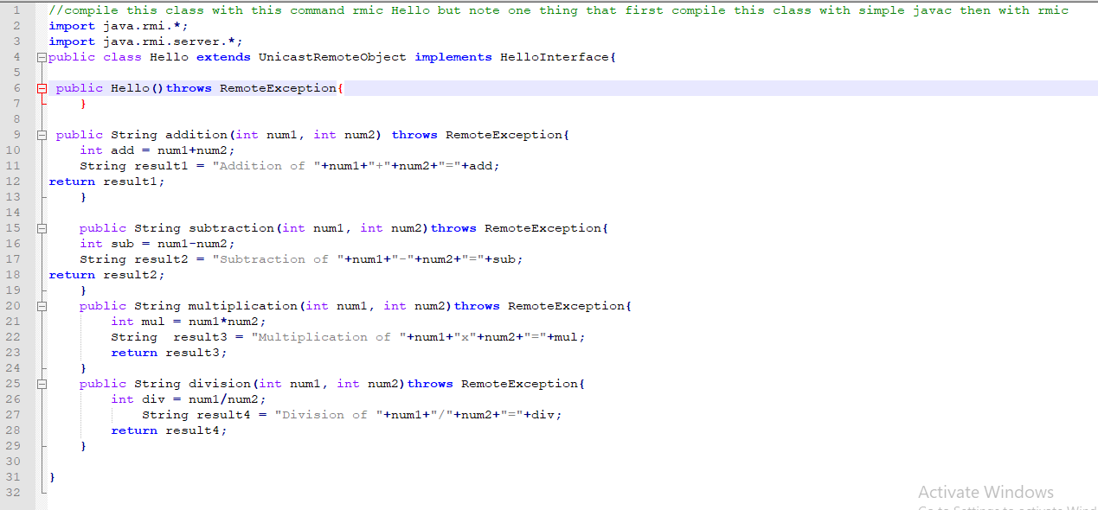

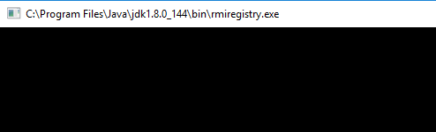

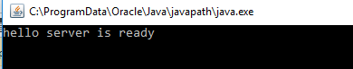

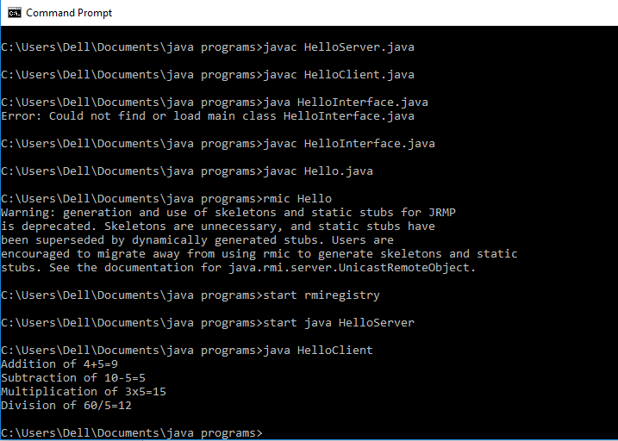

**Task 02: Create RMI program in which server sorts the numbers in ascending order.**

HelloServer.java

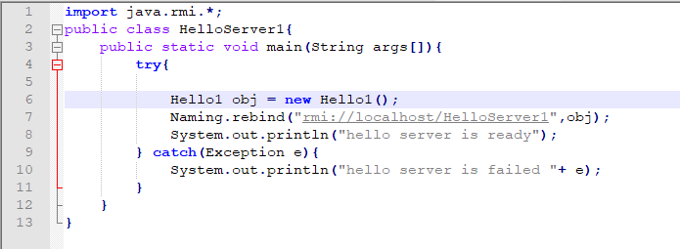

HelloClient1.java

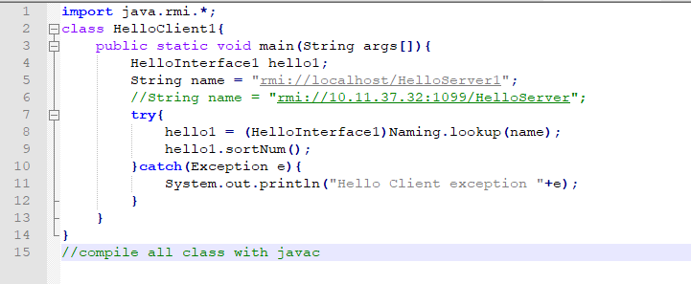

HelloInterface1.java

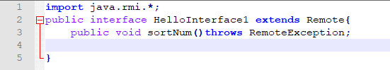

Hello1.java

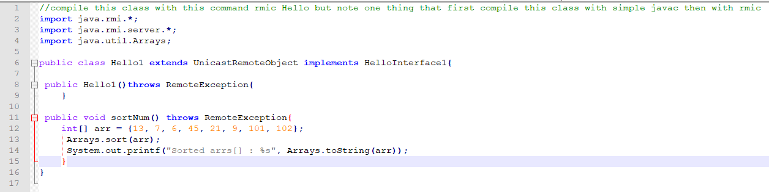

OUTPUT:

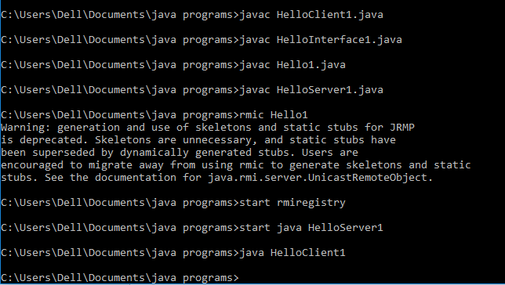

RMI REGISTRY:

